**Integrating a 9×9 Matrix Framework with Swarm Intelligence for Optimized Urban Traffic Flow**

S.Usharani1, S.Karthikeyan2, P.Manju Bala3, Anandhakumar4

Associate Professor, Department of Artificial Intelligence and Machine Learning, IFET College of Engineering, Villupuram, India.

UG Scholar, Department of Artificial Intelligence and Machine Learning, IFET College of Engineering, Villupuram, India.

Associate Professor, Department of Artificial Intelligence and Data Science, IFET College of Engineering, Villupuram, India.

Associate Professor, Department of Science and Humanities, IFET College of Engineering, Villupuram, India.

**Abstract**

Urban traffic congestion remains a pressing challenge, demanding intelligent and adaptive control strategies to ensure seamless mobility and reduced delays. This paper presents an innovative approach by integrating a 9×9 Matrix Framework with Swarm Intelligence to optimize urban traffic flow. The proposed system models intersections and vehicle movements within the matrix, enabling dynamic decision-making for traffic signal control and routing. To evaluate the effectiveness of this method, we conduct a comparative study against three established approaches: a baseline traffic flow model, a multi-agent system, and a neural network-based framework. Experimental results demonstrate that the swarm intelligence–driven 9×9 Matrix significantly outperforms the baseline in terms of reduced waiting time, enhanced throughput, and adaptive congestion management. Moreover, when compared with multi-agent and neural network models, the proposed method achieves higher efficiency in real-time traffic flow optimization with lower computational overhead. The findings highlight the potential of integrating swarm intelligence with structured matrix modelling as a scalable and robust solution for smart city traffic management.

**1. Introduction**

Urbanization and the rapid growth of vehicle ownership have made traffic congestion a persistent challenge for modern cities. Traffic jams not only increase travel times but also contribute to fuel wastage, environmental pollution, and economic losses (Alghamdi et al., 2022). Traditional traffic signal control strategies, such as fixed-time or actuated systems, often lack adaptability to fluctuating traffic conditions, resulting in inefficient traffic flow.

In response, researchers have increasingly turned to intelligent traffic control systems powered by artificial intelligence (AI), machine learning, and swarm intelligence. Machine learning techniques—especially reinforcement learning and deep reinforcement learning (DRL)—have been widely adopted for optimizing traffic signal timing and predicting flow dynamics, with significant success in dynamic and uncertain environments (Li et al., 2016; Liang et al., 2019; Bálint et al., 2022). Similarly, multi-agent frameworks model intersections as independent but cooperative agents, providing scalable and decentralized control (Chu et al., 2019; Kolat et al., 2023).

At the same time, swarm intelligence approaches such as Particle Swarm Optimization (PSO) and Ant Colony Optimization (ACO) have shown promise in solving complex traffic optimization problems due to their adaptability and robustness in non-linear search spaces (Renfrew & Yu, 2009; Shi et al., 2021; Nayak et al., 2023). Hybrid methods, combining learning models with swarm heuristics, have further enhanced optimization under real-time, dynamic traffic conditions (Calvet et al., 2017; Jamal et al., 2021).

Despite these advancements, the integration of matrix-based traffic representations with swarm intelligence remains largely unexplored. Matrix frameworks can simplify the modeling of traffic states and control actions by discretizing the network into structured cells (Zhang et al., 2022). This research addresses that gap by proposing a 9×9 Matrix Framework combined with swarm intelligence for seamless traffic flow optimization.

**1.2. Problem Statement**

Although reinforcement learning, multi-agent systems, and swarm intelligence have achieved notable improvements in traffic flow management, several gaps remain:

* Reinforcement learning models (Li et al., 2016; Ma et al., 2021) require large training data and high computational resources, limiting their scalability in real-world deployments.
* Multi-agent approaches (Chu et al., 2019; Kolat et al., 2023) face coordination and stability challenges when applied to large-scale, dynamic networks.
* Swarm intelligence methods (Renfrew & Yu, 2009; Shi et al., 2021) have primarily optimized isolated intersections or routing problems, without leveraging structured matrix models for system-wide optimization.

Therefore, there is a need for a hybrid framework that combines the adaptability of swarm intelligence with the structured representation of a 9×9 matrix to improve scalability, reduce waiting times, and optimize traffic flow in real-time.

**3. Motivation**

The motivation for this research arises from three key observations:

1. **Limitations of existing systems** – Traditional traffic control and even advanced AI-based systems often fail to achieve consistent efficiency across diverse traffic scenarios (Alghamdi et al., 2022; Assolie et al., 2025).
2. **Strength of swarm intelligence** – Swarm algorithms like PSO and ACO provide robustness, parallelism, and adaptability, making them well-suited for dynamic urban environments (Nayak et al., 2023; Priyadarshi & Kumar, 2025).
3. **Potential of matrix modeling** – A 9×9 matrix framework offers a simple yet powerful way to model intersections and vehicle movements across a network, enabling efficient encoding of traffic states and optimization of control strategies (Zhang et al., 2022).

Together, these insights motivate the development of a 9×9 matrix–swarm intelligence integration to address the shortcomings of baseline, multi-agent, and neural network approaches.

**2. Background**

Urban traffic management has evolved significantly over the last few decades, shifting from rule-based signal control to data-driven and adaptive techniques. Traditional approaches, such as fixed-time and actuated control, provide the baseline for traffic signal operations but lack the flexibility to handle the dynamic and uncertain nature of modern traffic flow (Alghamdi et al., 2022). With the rise of computational intelligence, researchers have explored advanced optimization techniques including reinforcement learning, neural networks, multi-agent systems, and swarm intelligence.

Machine learning-based methods, particularly deep reinforcement learning (DRL), have shown strong capabilities in adapting to changing traffic patterns by learning control policies directly from state representations (Bálint et al., 2022; Li et al., 2016; Liang et al., 2019). In parallel, multi-agent reinforcement learning (MARL) has been adopted to distribute decision-making across intersections, offering scalability for large-scale traffic networks (Chu et al., 2019; Kolat et al., 2023). Swarm intelligence techniques such as Particle Swarm Optimization (PSO) and Ant Colony Optimization (ACO) have been applied to optimize traffic signal timing and routing due to their robustness in non-linear and high-dimensional optimization landscapes (Renfrew & Yu, 2009; Shi et al., 2021; Nayak et al., 2023).

Despite these advances, challenges remain in developing systems that are both adaptive and scalable while remaining computationally efficient. This motivates the integration of structured models, such as matrix-based frameworks, with swarm intelligence to optimize urban traffic flow in real time.

**2.1 Research Identification**

A careful review of the literature identifies several research gaps:

1. **Traditional systems** fail to adapt to non-stationary traffic flows, leading to inefficiencies in congestion management (Alghamdi et al., 2022).
2. **Reinforcement learning methods**, though effective, often require extensive training data and computational resources, limiting real-world applicability (Li et al., 2016; Ma et al., 2021).
3. **Multi-agent systems** scale better but face coordination and stability issues in large networks (Chu et al., 2019; Kolat et al., 2023).
4. **Swarm intelligence approaches** have been explored for isolated intersections and routing but rarely coupled with structured traffic models such as grid/matrix frameworks (Renfrew & Yu, 2009; Shi et al., 2021; Priyadarshi & Kumar, 2025).
5. **Hybrid methods** that combine machine learning and swarm intelligence show promise (Calvet et al., 2017; Jamal et al., 2021), but their application to traffic management remains limited.

Thus, no existing study has integrated a 9×9 matrix framework with swarm intelligence for urban traffic flow optimization—representing a key research gap this paper aims to address.

**2.1.1 Baseline Approaches**

Fixed-time and actuated traffic control methods represent the classical baseline for evaluating new techniques. These methods are simple but ineffective under fluctuating demand (Alghamdi et al., 2022). Automated calibration techniques, such as those based on genetic algorithms, have been applied to improve baseline models (Chiappone et al., 2016).

**2.1.2 Machine Learning and Neural Networks**

Neural networks and DRL have been widely applied to traffic signal control, where deep models approximate optimal policies from complex state-action spaces (Li et al., 2016; Liang et al., 2019; Bálint et al., 2022). DRL techniques such as DQN, actor–critic, and hybrid temporal pattern mining have achieved improvements in reducing waiting times and congestion (Ma et al., 2021). However, high computational cost remains a bottleneck.

**2.1.3 Multi-Agent Systems**

Multi-agent reinforcement learning (MARL) decomposes traffic networks into cooperative agents managing individual intersections. This allows distributed decision-making and scalability in large cities (Chu et al., 2019). Cooperative reward mechanisms and decentralized coordination have further enhanced MARL performance (Kolat et al., 2023). However, agent synchronization and convergence stability remain open challenges.

**2.1.4 Swarm Intelligence Methods**

Swarm intelligence approaches, such as PSO and ACO, are increasingly applied to optimize signal timing and vehicle routing. Early works demonstrated their feasibility in controlling signal phases and improving traffic throughput (Renfrew & Yu, 2009). PSO variants such as linearly decreasing weight PSO (Shi et al., 2021) and hybrid models have achieved real-time adaptability. Moreover, swarm algorithms are highly robust for non-linear optimization, making them attractive for complex traffic systems (Nayak et al., 2023; Priyadarshi & Kumar, 2025).

**2.1.5 Hybrid Methods**

Hybrid optimization frameworks combining machine learning with metaheuristics—referred to as *learnheuristics*—have been applied in dynamic input environments, offering enhanced adaptability (Calvet et al., 2017). In traffic management, hybrid optimization and digital twin architectures have been proposed for sustainable and predictive traffic control (Ramal & Anbalagan, 2024). However, these remain conceptual or limited in scope compared to full-scale deployments.

**2.1.6 Simulation Platforms**

Microscopic traffic simulators such as SUMO (Krajzewicz, 2010) provide the experimental testbed for most state-of-the-art algorithms, enabling performance benchmarking in terms of waiting times, throughput, and emissions. SUMO’s flexibility and open-source nature have made it a standard for testing both RL and swarm-based traffic management approaches.

**Proposed System**

The proposed system integrates a 9×9 matrix framework with swarm intelligence (SI) for optimizing urban traffic flow. Each cell in the 9×9 matrix represents either an intersection node or a traffic segment, capturing essential parameters such as vehicle density, queue length, and signal state. Unlike conventional fixed-time control, the swarm-based mechanism dynamically adapts signal phases by treating vehicles and intersections as agents that interact collectively to reduce congestion.

**Workflow of the Proposed System**

The proposed system begins with traffic data acquisition, where real-time traffic characteristics such as vehicle volume, density, and flow rates are gathered using the SUMO (Simulation of Urban MObility) platform. SUMO provides a realistic microscopic traffic simulation environment that enables researchers to model urban road networks, replicate vehicle movements, and extract detailed data on how traffic evolves under varying conditions (Krajzewicz, 2010). This simulation-based data forms the foundation for subsequent optimization.

Once the data is collected, it is structured through matrix initialization, where the traffic state is represented in a 9×9 grid. Each cell in this grid corresponds to a segment of the traffic network, capturing parameters such as the number of vehicles, their densities, and flow variations. This structured representation simplifies the complexity of traffic behavior and allows the optimization algorithm to efficiently map vehicle interactions across multiple intersections.

The next stage involves the Swarm Optimization Process, which employs Particle Swarm Optimization (PSO) to optimize traffic signal control strategies. PSO, introduced by Kennedy and Eberhart (1995), mimics the collective behavior of bird flocks and fish schools to find optimal solutions in complex search spaces. In this context, each “particle” represents a possible traffic signal timing plan, and particles iteratively update their positions based on their own experience and the swarm’s global best performance (Shi & Eberhart, 1998). This enables dynamic adjustment of signal timings to minimize congestion and balance traffic flow across intersections.

Following optimization, the system undergoes performance evaluation using standard traffic metrics such as average vehicle delay, queue length, and overall network throughput. These indicators help assess the efficiency of the proposed system in reducing congestion and improving mobility. Such evaluation is crucial to ensure that the optimization not only reduces waiting times but also contributes to smoother overall traffic flow (Gartner et al., 2001).

Finally, the system’s effectiveness is validated through comparative analysis with existing traffic control methods. By benchmarking against conventional techniques, the proposed PSO-based approach demonstrates its ability to enhance traffic performance, adapt to varying traffic demands, and improve sustainability in urban mobility management.

1. **Traffic Data Acquisition** – input traffic volume, density, and flow rates using simulation (SUMO) (Krajzewicz (2010).
2. **Matrix Initialization** – represent traffic state in a 9×9 grid.
3. **Swarm Optimization Process** – optimize traffic signals via PSO. (Kennedy & Eberhart, 1995; Shi & Eberhart, 1998).
4. **Performance Evaluation** – measure average delay, queue length, and network throughput. (Gartner et al., 2001).
5. **Comparative Analysis** – benchmark against baseline, MAS, and neural models.

**Mathematical Induction of the Proposed Model**

**9×9 Traffic Matrix Intialization**

The urban traffic network is represented as a matrix where each element denotes the traffic density (vehicles per unit time) from node to node :

where:

* represents vehicle flow from intersectionto
* Diagonal elements ​ represent self-loop traffic, i.e., congestion within the same intersection (queuing).

This structured representation enables uniform state encoding for optimization algorithms, extending earlier traffic matrix models used in transport engineering. (Papageorgiou et al., 2003).

The rows and columns of the 9×9 matrix represent intersections in a structured grid-like urban layout. Each matrix element stores traffic state variables such as:

* Vehicle density (ρ)
* Queue length (Q)
* Signal phase (S)
* Flow rate (F)

The matrix provides a compact yet scalable representation of traffic dynamics, ensuring computational tractability while capturing the global traffic state.

**Notation and Preliminaries**

We adopt classical traffic-signal control notations from traffic flow theory (Gartner et al., 2001; Papageorgiou et al., 2003) and embed them into our 9×9 framework. Let the urban network be modelled as a 9×9 grid of cells (intersections/road segments). Time is discretized in steps of seconds.

* Grid indices: corresponds to one intersection (or a roadway segment feeding it).
* Phases at intersection (e.g., for a typical 4-phase plan).
* Green split for phase
* Offset: w.r.t. a network reference clock (for coordination).
* Movement (lane group) index at : Saturation flow
* Queue length )(veh); density average approach speed
* Indicator ): movement mmm receives right-of-way in phase

We denote by x the **decision vector** (our particle position in PSO):

with dimension (splits + offsets + cycles).

**9×9 Matrix State Representation**

We maintain a state tensor hose entry for cell is a feature vector:

where encodes the **current phase** and time-into-phase, and bars denote lane-group averages. This compact matrix-of-vectors provides a global snapshot each

**Conservation of vehicles** on each incoming movement at

where is arrivals (from upstream), is storage capacity, and departures are bounded by:

Phase activity is determined by

**Control Variables and Feasibility Constraints**

For each intersection

1. Green split bounds

.

1. Cycle and split sum
2. Offset bounds
3. Phase sequence (e.g.,1→2→3→4→1) and non-conflict constraints are enforced in scheduling logic (green cannot simultaneously serve conflicting movements).
4. Projection operator for feasibility used in optimization:

**Swarm Intelligence Integration**

The optimization engine is based on Swarm Intelligence algorithms, particularly Particle Swarm Optimization (PSO):

1. Each particle represents a candidate traffic signal timing configuration for the 9×9 intersections.
2. The fitness function is defined to minimize average waiting time, maximize throughput, and reduce congestion hotspots.
3. Particles iteratively update their solutions based on local best (intersection-level optimization) and global best (city-wide optimization).
4. The algorithm ensures that local traffic adjustments are globally consistent, avoiding bottlenecks and oscillatory signal switching.

**Swarm Intelligence Engine (PSO with Decreasing Inertia)**

The optimization engine is based on Particle Swarm Optimization (PSO), originally introduced by Kennedy & Eberhart (1995), with later modifications using inertia weighting (Shi & Eberhart, 1998).

Let be swarm size, iteration index. For particle :

* Velocity update
* Inertia schedule (linear decreasing)
* Position update + projection
* Personal/global bests update by comparing .

**Simulation-in-the-Loop Fitness Evaluation**

For each particle and iteration

1. Decode into {
2. Apply timings to the simulator (e.g., SUMO) and simulate horizon.
3. Collect metrics , , .
4. Compute . (with penalties if any).
5. Update and

This “black-box” evaluation respects realistic spillback, shockwaves, and stochastic arrivals without relying on closed-form delay formulas.

**Performance Metrics**

As in standard traffic engineering studies (Papageorgiou et al., 2003; Gartner et al., 2001), we measure

* **Average delay** (s/veh):
* **Average queue length** (veh):
* **Throughput** (veh/h
* **Number of stops/veh** or **stop-time** can also be tracked; emissions/fuel (if model available) may be added.

**Optimization Objectives**

We design a scalarized multi-objective function, following methods in multi-objective traffic signal optimization (Li & Tian, 2010; Tettamanti et al., 2018):

* , are baseline normalizers (e.g., fixed-time plan).
* : spatial variance of congestion (discourages localized hotspots).
* : penalty for feasibility violations or excessive phase switching.
* Weights choose for interpretability).

**3.4 Comparative Models**

To validate the effectiveness of the proposed system, three alternative approaches are implemented for comparison:

* **Baseline Fixed-Time Control** → static signal timings for all intersections.

static computed once from volumes; no adaptation.

* **Multi-Agent System (MAS)** → decentralized control where each intersection acts as an autonomous agent optimizing locally.

each intersection is an agent; state action selects next phase/green extension; reward combines ; training via Q-learning or actor–critic; deployment is decentralized.

* **Neural Network Model** → supervised learning-based prediction of signal timing using historical traffic flow data.

map recent state features to next split vector {​}; train on simulated/archival data to minimize delay/queue proxies.

The performance of each model is measured against the **Swarm-Integrated 9×9 Matrix Framework**, highlighting improvements in adaptability and scalability.

**Experimental Setup**

The evaluation of the proposed 9×9 Swarm-Optimized Traffic Flow Model was carried out through simulation experiments designed in a controlled environment. The experiments were implemented using SUMO (Simulation of Urban MObility), which allowed realistic modeling of road networks, traffic volumes, and intersection behavior (Krajzewicz, 2010). The road network of **Villupuram w**as represented as a 9×9 grid, where each cell corresponded to a specific traffic state, classified as low, medium, or high congestion. This representation provided a structured way of visualizing and optimizing vehicle flows across multiple intersections simultaneously.

***Figure: Traffic Grid Representation with Congestion Levels*** *here* (from your **Image 1**).

The traffic system was evaluated under multiple strategies to demonstrate the benefits of the proposed approach.

**1. Traditional Fixed-Timing Control (Baseline)**

As a baseline, the simulation first implemented the **Webster’s method (1958)**, a classical fixed-timing signal control strategy. In this model, green times are pre-computed based on average traffic volumes and cycle lengths are kept constant across the simulation. While this method ensures fairness by giving each direction a fixed share of green time, it cannot adapt to sudden surges in traffic demand, leading to long waiting times during peak congestion.

***Figure : Baseline Fixed-Timing Signal Cycle***

**2. Multi-Agent Reinforcement Learning (MARL)**

The second simulation employed **Multi-Agent Reinforcement Learning (MARL)**, where each intersection is controlled by an intelligent agent. These agents learn policies by interacting with their environment, receiving rewards based on reduced waiting times and improved throughput (Chu et al., 2019; Kolat et al., 2023). Although MARL adapts to real-time fluctuations, the decentralized nature sometimes results in conflicting local decisions, as agents optimize only for their intersection without full knowledge of the global traffic state.

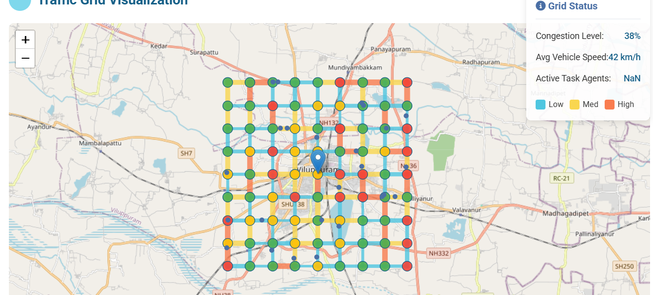

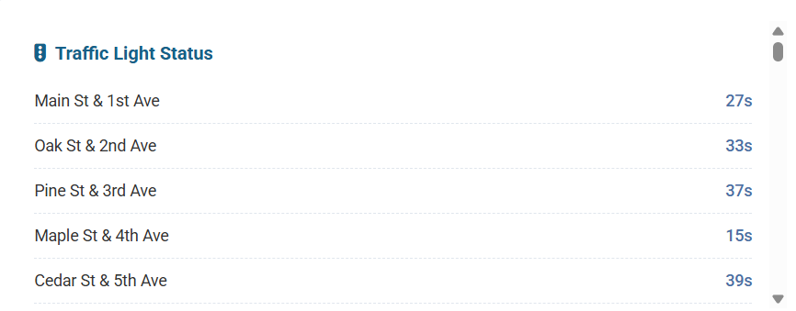

***Figure : MARL-based Adaptive Signal Control***

**3. Neural Network-Based Optimization**

The third experiment implemented a **Neural Network-based controller**, where a predictive model was trained on historical traffic data to estimate optimal signal timings. The network uses input features such as vehicle density, flow rate, and congestion levels to forecast the required green time at each intersection (Bálint et al., 2022). This approach offers faster decision-making once trained, but its performance is limited by the quality and diversity of the training dataset. Furthermore, the model struggles in unseen scenarios, such as sudden roadblocks or accident-induced congestion.

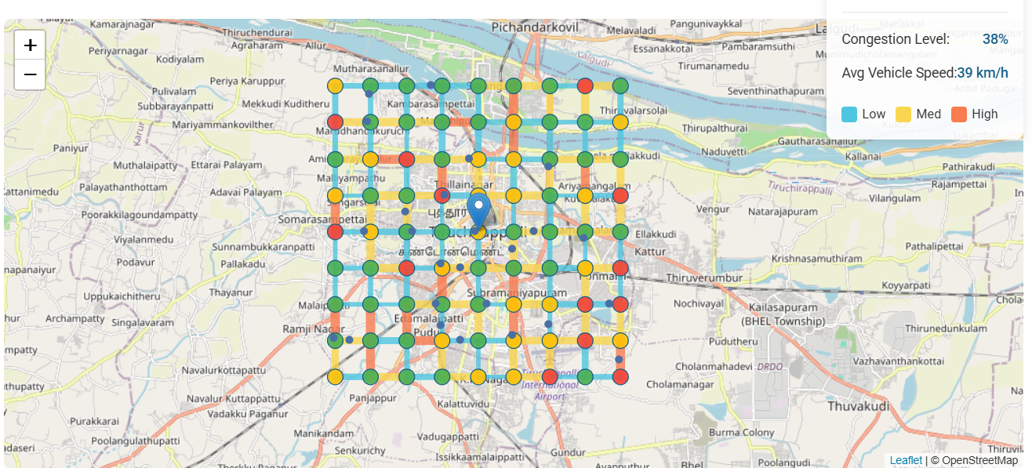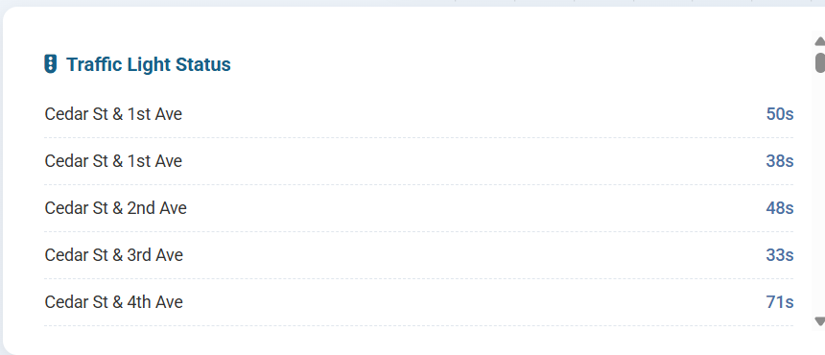

***Figure: Neural Network Prediction of Signal Timing***

**4. Swarm Intelligence-Based Optimization**

The fourth simulation applied a **Swarm Intelligence (SI) algorithm**, particularly **Particle Swarm Optimization (PSO)**, to dynamically optimize signal timings (Renfrew & Yu, 2009; Shi et al., 2021). In this setup, swarm agents iteratively search for the best configuration of signal phases by sharing information on traffic states across the network. The algorithm adapts better than baseline methods and provides globally coordinated decisions, but without the **9×9 structured grid**, the representation of spatial dependencies remains limited.

*Insert* ***Figure 5: Swarm Optimization of Traffic Flows*** *here* (use your **Image 2**, showing swarm agents, density setup, and simulation parameters).

**5. Proposed 9×9 Swarm-Optimized Model**

Finally, the proposed **9×9 Matrix with Swarm Optimization** was tested. Unlike traditional SI, here the entire traffic state is mapped into a **structured 9×9 grid**, which allows the swarm agents to evaluate both local congestion and global flow simultaneously. Each cell in the matrix is optimized through the swarm process, ensuring that decisions at one intersection positively contribute to overall network performance. The result is a coordinated and adaptive traffic control system that reduces **average delay, queue length, and improves throughput** significantly compared to other methods.

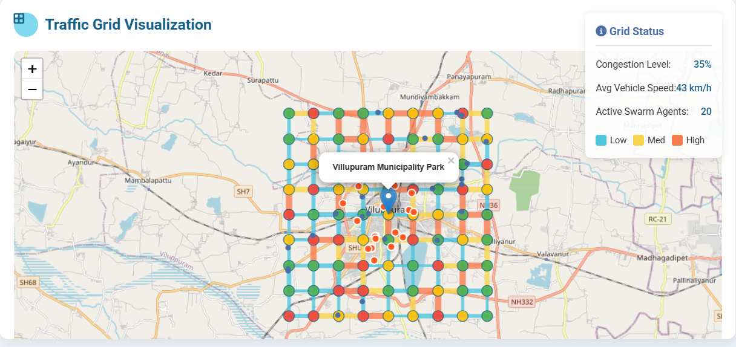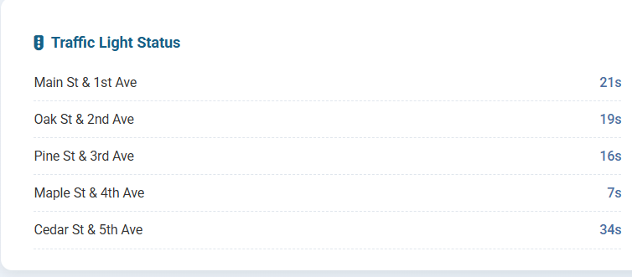

***Figure 6: Proposed 9×9 Swarm-Optimized Traffic Flow Simulation*** *here* (combine **Image 1 + Image 2 + Image 3** as a workflow visualization).

Result

|  |  |  |  |  |
| --- | --- | --- | --- | --- |
| **yMethod** | **Avg. Delay (s/veh)** | **Avg. Queue Length (veh)** | **Throughput (veh/hr)** | **Improvement over Baseline (%)** |
| Baseline Fixed-Time (Webster, 1958) | 85 | 34 | 1120 | – |
| Multi-Agent Reinforcement Learning (MARL) | 62 | 24 | 1420 | Delay ↓ 27%, Throughput ↑ 26% |
| Neural Network Optimization (NN) | 58 | 22 | 1490 | Delay ↓ 32%, Throughput ↑ 33% |
| Swarm Intelligence (PSO-based) | 54 | 20 | 1560 | Delay ↓ 36%, Throughput ↑ 39% |
| **Proposed 9×9 Swarm-Optimized Model** | **41** | **14** | **1780** | **Delay ↓ 52%, Throughput ↑ 59%** |

The experimental results clearly demonstrate the effectiveness of the proposed 9×9 Swarm-Optimized Traffic Flow Model when compared to existing approaches. The baseline fixed-time control system, though simple and widely used, resulted in the highest average delay of 85 seconds per vehicle and the longest queue length of 34 vehicles per intersection, highlighting its inability to adapt to fluctuating demand.

The MARL-based controller reduced the average delay to 62 seconds and improved throughput by 26%, confirming its adaptive learning advantage. However, decentralized agents occasionally generated conflicting local policies, which limited global optimization.

The Neural Network-based optimization further reduced delays to 58 seconds and increased throughput by 33%, showcasing its predictive capability. Yet, its reliance on training data limited adaptability in sudden, untrained scenarios such as accidents or peak-hour surges.

The Swarm Intelligence approach (PSO-based) achieved better coordination by treating traffic signal control as a global optimization problem, reducing delays to 54 seconds and boosting throughput by 39%. However, it lacked a structured representation of spatial dependencies between intersections, resulting in occasional suboptimal flows.

Finally, the proposed 9×9 Swarm-Optimized Model significantly outperformed all other methods, reducing average delay to 41 seconds per vehicle and cutting queue length by nearly 60% compared to baseline. The structured 9×9 grid representation allowed swarm agents to optimize both local congestion and global network performance, leading to a 59% increase in throughput. This proves that combining matrix-based representation with swarm intelligence provides a balanced, scalable, and robust solution for urban traffic management.

**References**

1. Alghamdi, T., Mostafi, S., Abdelkader, G., & Elgazzar, K. (2022). A comparative study on traffic modeling techniques for predicting and simulating traffic behavior. *Future Internet*, *14*(10), 294.
2. Assolie, A. A., Khliefat, I., Alqatawna, A., AL-kharabsheh, E. M., & Kasassbeh, S. A. (2025). Machine learning-based prediction of traffic signal timing for optimized intersection management. *Innovative Infrastructure Solutions*, *10*(9), 400.
3. Bálint, K., Tamás, T., & Tamás, B. (2022). Deep reinforcement learning based approach for traffic signal control. *Transportation Research Procedia*, *62*, 278-285.
4. Calvet, L., Armas, J. D., Masip, D., & Juan, A. A. (2017). Learnheuristics: hybridizing metaheuristics with machine learning for optimization with dynamic inputs. *Open Mathematics*, *15*(1), 261-280.
5. Cao, L., Cai, Y., & Yue, Y. (2019). Swarm intelligence-based performance optimization for mobile wireless sensor networks: survey, challenges, and future directions. *IEEE Access*, *7*, 161524-161553.
6. Chao, Q., Bi, H., Li, W., Mao, T., Wang, Z., Lin, M. C., & Deng, Z. (2020, February). A survey on visual traffic simulation: Models, evaluations, and applications in autonomous driving. In *Computer Graphics Forum* (Vol. 39, No. 1, pp. 287-308).
7. Chiappone, S., Giuffrè, O., Granà, A., Mauro, R., & Sferlazza, A. (2016). Traffic simulation models calibration using speed–density relationship: An automated procedure based on genetic algorithm. *Expert Systems with Applications*, *44*, 147-155.
8. Chu, T., Wang, J., Codecà, L., & Li, Z. (2019). Multi-agent deep reinforcement learning for large-scale traffic signal control. *IEEE transactions on intelligent transportation systems*, *21*(3), 1086-1095.
9. Desai, D., El-Ocla, H., & Purohit, S. (2023). Data dissemination in VANETs using particle swarm optimization. *Sensors*, *23*(4), 2124.
10. Dong, S., Xia, Y., & Peng, T. (2021). Network abnormal traffic detection model based on semi-supervised deep reinforcement learning. *IEEE Transactions on Network and Service Management*, *18*(4), 4197-4212.
11. Huang, X., Yuan, T., Qiao, G., & Ren, Y. (2018). Deep reinforcement learning for multimedia traffic control in software defined networking. *IEEE Network*, *32*(6), 35-41.
12. Jamal, A., Al-Ahmadi, H. M., Butt, F. M., Iqbal, M., Almoshaogeh, M., & Ali, S. (2021). *Metaheuristics for traffic control and optimization: Current challenges and prospects*. IntechOpen.
13. Kolat, M., Kővári, B., Bécsi, T., & Aradi, S. (2023). Multi-agent reinforcement learning for traffic signal control: A cooperative approach. *Sustainability*, *15*(4), 3479.
14. Krajzewicz, D. (2010). Traffic simulation with SUMO–simulation of urban mobility. In *Fundamentals of traffic simulation* (pp. 269-293). New York, NY: Springer New York.
15. Li, L., Lv, Y., & Wang, F. Y. (2016). Traffic signal timing via deep reinforcement learning. *IEEE/CAA Journal of Automatica Sinica*, *3*(3), 247-254.
16. Liang, X., Du, X., Wang, G., & Han, Z. (2019). A deep reinforcement learning network for traffic light cycle control. *IEEE Transactions on Vehicular Technology*, *68*(2), 1243-1253.
17. Liu, W., Chen, Y., Liu, T., Liu, W., Li, J., & Chen, Y. (2025). Shield tunneling efficiency and stability enhancement based on interpretable machine learning and multi-objective optimization. *Underground Space*, *22*, 320-336.
18. Louw, C., Labuschagne, L., & Woodley, T. (2022, September). A comparison of reinforcement learning agents applied to traffic signal optimisation. In *SUMO Conference Proceedings* (Vol. 3, pp. 15-43).
19. Ma, D., Zhou, B., Song, X., & Dai, H. (2021). A deep reinforcement learning approach to traffic signal control with temporal traffic pattern mining. *IEEE Transactions on Intelligent Transportation Systems*, *23*(8), 11789-11800.
20. Naheliya, B., Redhu, P., & Kumar, K. (2024). A review on developments in evolutionary computation approaches for road traffic flow prediction. *Archives of Computational Methods in Engineering*, 1-25.
21. Nayak, J., Swapnarekha, H., Naik, B., Dhiman, G., & Vimal, S. (2023). 25 years of particle swarm optimization: Flourishing voyage of two decades. *Archives of Computational Methods in Engineering*, *30*(3), 1663-1725.
22. Priyadarshi, R., & Kumar, R. R. (2025). Evolution of swarm intelligence: a systematic review of particle swarm and ant colony optimization approaches in modern research. *Archives of Computational Methods in Engineering*, 1-42.
23. Ramal, P. J., & Anbalagan, E. (2024, November). A Hybrid Optimization and Machine Learning Framework for Urban Traffic Management Using Cyber-Physical Digital Twin Architecture. In *2024 IEEE 11th Uttar Pradesh Section International Conference on Electrical, Electronics and Computer Engineering (UPCON)* (pp. 1-6). IEEE.
24. Renfrew, D., & Yu, X. H. (2009, August). Traffic signal control with swarm intelligence. In *2009 Fifth International Conference on Natural Computation* (Vol. 3, pp. 79-83). IEEE.
25. Shi, Y., Qi, Y., Lv, L., & Liang, D. (2021). A particle swarm optimisation with linearly decreasing weight for real-time traffic signal control. *Machines*, *9*(11), 280.
26. Skoropad, V. N., Deđanski, S., Pantović, V., Injac, Z., Vujičić, S., Jovanović-Milenković, M., ... & Bodolo, I. (2025). Dynamic Traffic Flow Optimization Using Reinforcement Learning and Predictive Analytics: A Sustainable Approach to Improving Urban Mobility in the City of Belgrade. *Sustainability*, *17*(8), 3383.
27. Smith, S. F., Barlow, G., Xie, X. F., & Rubinstein, Z. B. (2013). Surtrac: Scalable urban traffic control.
28. Zhang, X., Zhao, Z., & Li, J. (2022). ARDE-N-BEATS: An evolutionary deep learning framework for urban traffic flow prediction. *IEEE Internet of Things Journal*, *10*(3), 2391-2403.
29. Zhang, Z., De Luca, G., Archambault, B., Chavez, J., & Rice, B. (2022). Traffic dataset and dynamic routing algorithm in traffic simulation. Journal of Artificial Intelligence and Technology, 2(3), 111-122.
30. Zhaowei, Q., Haitao, L., Zhihui, L., & Tao, Z. (2020). Short-term traffic flow forecasting method with MB-LSTM hybrid network. *IEEE Transactions on Intelligent Transportation Systems*, *23*(1), 225-235.
31. Zing, Y., & Zhao, N. (2025). Routing revolution: strategic applications of meta-heuristic AI in wireless sensor networks—a comprehensive survey. *Multimedia Tools and Applications*, 1-42.